Data Analyst Repo ReadMe

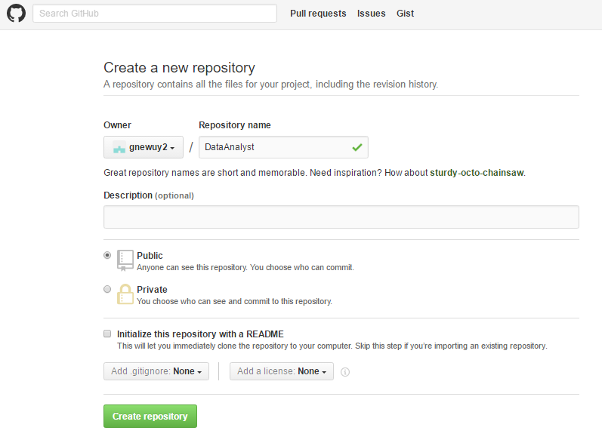

echo "# DataAnalyst" >> README.md

git init

git add README.md

git commit -m "first commit"

git remote add origin https://github.com/gnewuy2/DataAnalyst.git

git push -u origin master

cd Desktop/DS

mkdir git

cd git

git clone https://github.com/gnewuy2/DataAnalyst.git

Result: folder git/DataAnalyst (with a README.md)

git pull *remotename* *branchname*

*git init*

git add .

# Adds the file to your local repository and stages it for commit. To unstage a file, use 'git reset HEAD YOUR-FILE'.

1. Commit the file that you've staged in your local repository.

git commit -m "Add existing file"

# Commits the tracked changes and prepares them to be pushed to a remote repository. To remove this commit and modify the file, use 'git reset --soft HEAD~1' and commit and add the file again.

git remote add origin *remote repository URL*

1. [Push the changes](https://help.github.com/articles/pushing-to-a-remote) in your local repository to GitHub.
2. git push origin your-branch
3. # Pushes the changes in your local repository up to the remote repository you specified as the origin